**CA 5 | Nathan Lee Jia Neng | A0184649M | E08**

Academic discourse refers to the way of thinking and writing systematically to persuade readers, using the language in the academy (“Academic discourse and the ES1103 Pedagogical Approach”, 2018). Therefore, in an academic essay, it is important to be able to link the ideas in a cohesive manner in order to express the thoughts to the intended audience effectively. As a mechanical engineering student, two of my core modules, namely EG1111 and EG1112(Engineering Practices and principles I &II) required students to submit a group lab report and a group technical report respectively for general readers who are not in the field of STEM. Both reports are near transfers from ES1103 as the same concepts can be applied to the reports, except for the minor switch from APA referencing to IEEE referencing. Through ES1103, I have acquired knowledge in text cohesion and organization, which helped enhance my performance in disciplinary writings.

I first came to realize that I should be improving on my academic writing skills after reviewing my grade and feedback in my first group lab report. My weakness was in expressing my thoughts systematically as I had always presented my ideas without linking them together. However, presenting a well-organized lab report is important in order to communicate our findings to the readers as readers could not read our minds to follow our flow of thoughts (“Cohesive texts”, 2018a). Therefore, I found the first lesson in Week 5 on thematic progression to be useful. Thematic progression refers to the different ways in which hyper-themes in a text could be linked together to create a flow(“Cohesive texts”, 2018b). Through the lesson on thematic progression, I had a clearer understanding on the concepts on macro-theme, which is the thesis statement of the paper, and hyper-themes, which are sub-themes branched out from the macro-theme(“Cohesive texts”, 2018c). The concepts taught in tool kits 1 (“Cohesive texts”, 2018d) that included details that help link the hyper-themes with the macro-theme, namely conjunctions, general nouns and lexical sets has also helped improve the coherence of my technical writing report, as shown in figure 1.

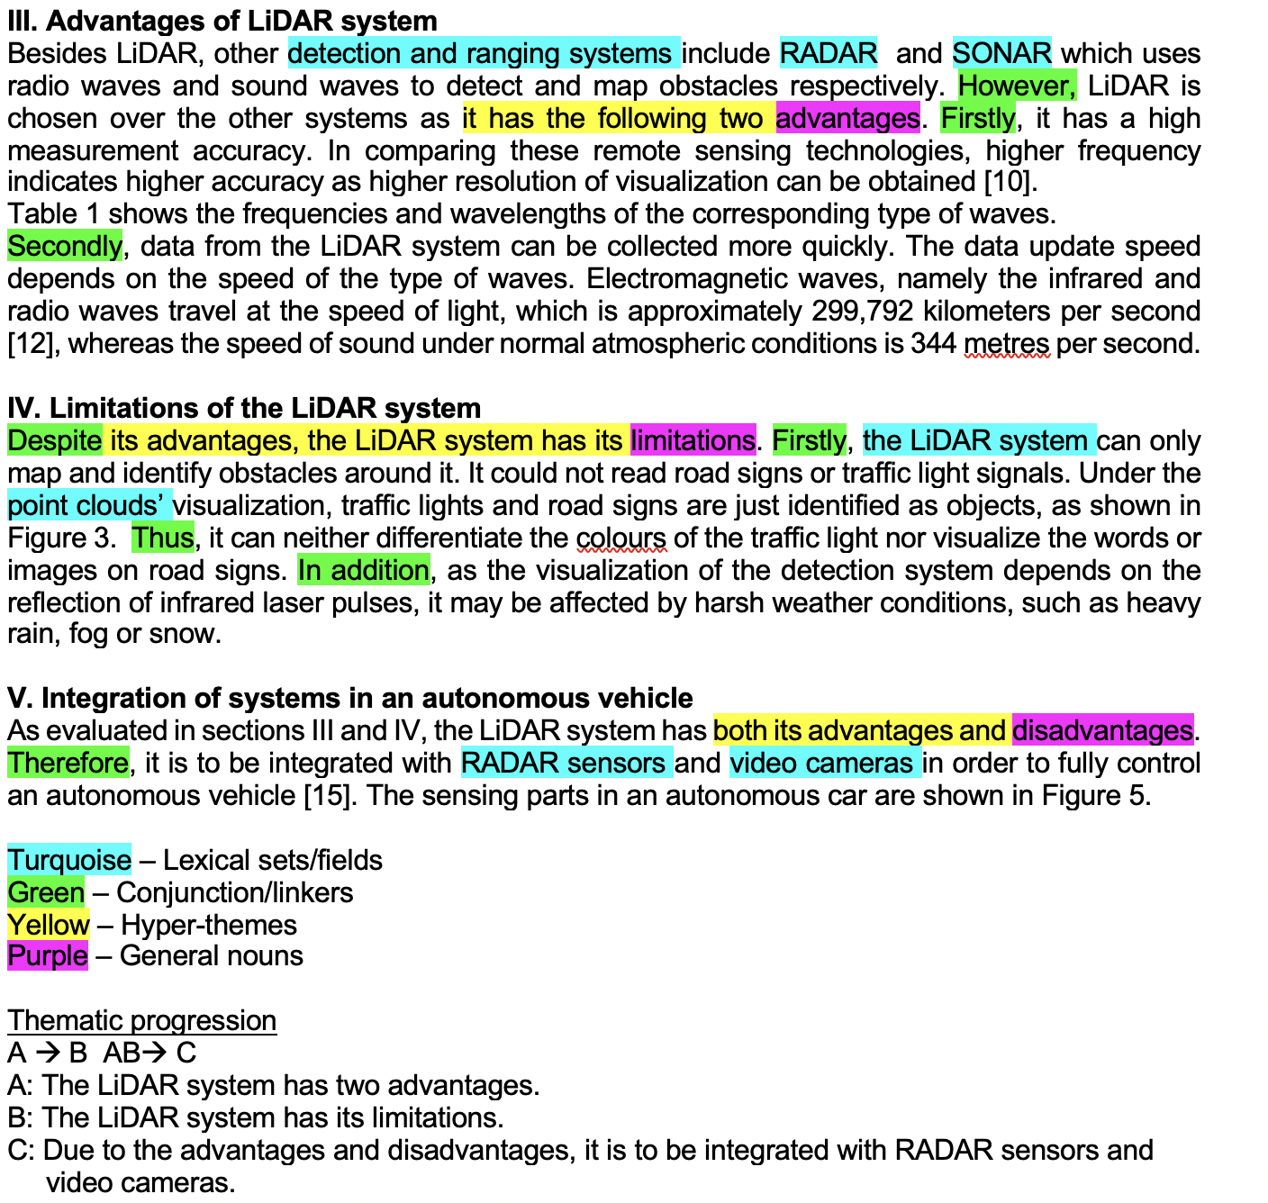*Figure 1: EG 1112 Engineering Practices and Principles II – Group Technical Report (Lee & Pratama 2019a)*

Furthermore, the second tutorial in week 5 about writing introductions reminded me to review my first technical report in EG1111 as I was given the task to write the introduction of the lab report for my group. The introduction for the lab report is shown in figure 2.

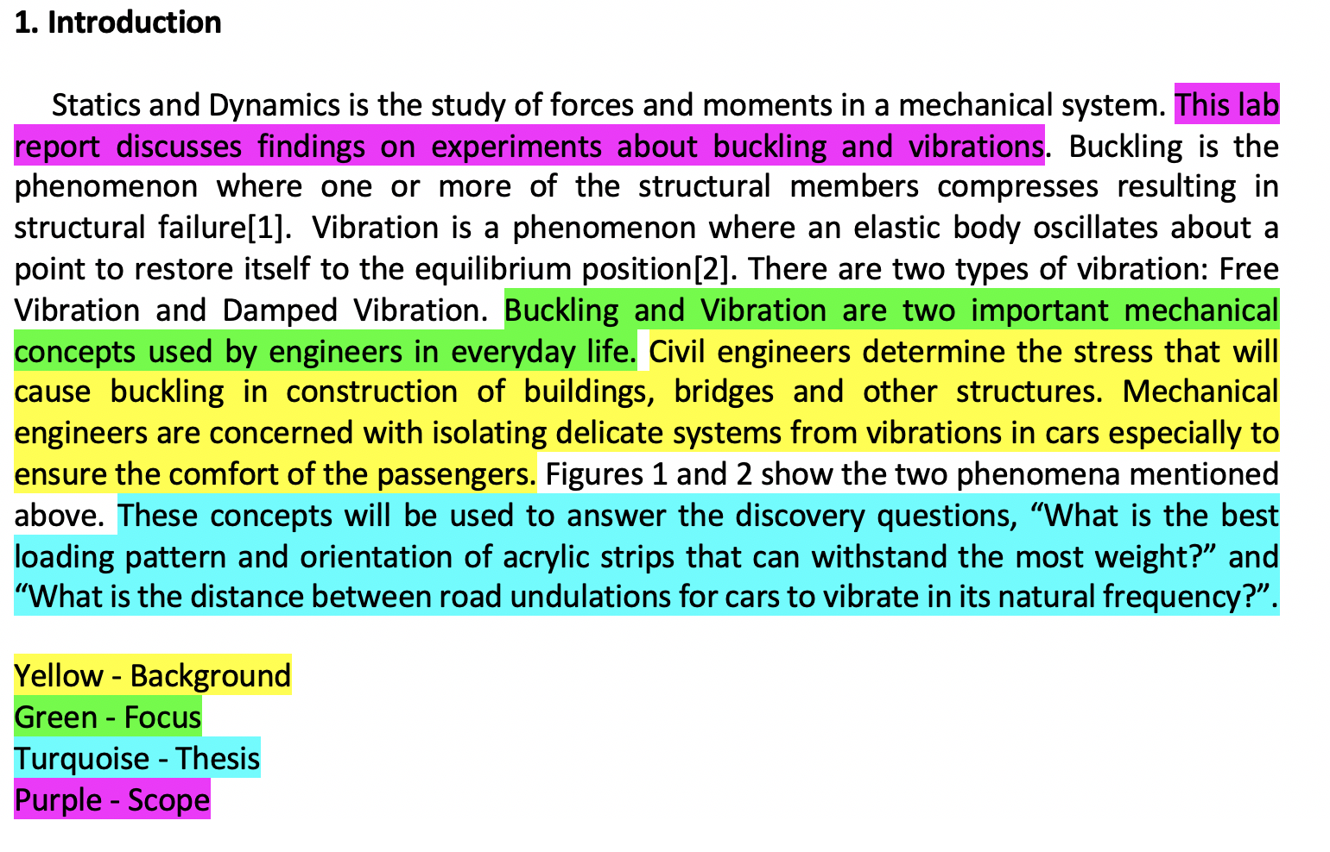*Figure 2: EG 1111 Engineering Practices and Principles I – Group Lab Report (Lee,N., Lee,C.Y., Kumar, Tan, G.T., & Tan, R.Q., 2018)*

In academic writing, the introduction is usually structured like an inverted triangle to organize the ideas and show the development from general to more focused contents(“Writing Introductions”, 2018a). At the top of the inverted triangle is the background, which is an overview of the topic linking directly to the task given. Followed by the background is the focus of the text, narrowing down to a focused issue related to the topic. Following that is the thesis statement, which communicates the main message of the text. At the bottom of the triangle is the scope of the writing, which includes the main topics discussed in the paper(“Writing Introductions”, 2018b). Linking back the concepts of writing a good introduction to my group’s lab report figure 2, I realized that the sequences of the elements in the introduction, as highlighted were disorganized, which lead to the disruption in the linkage of the ideas. Figure 3 shows the introduction of the technical report in EG 1112 as I transferred my knowledge from ES1103 to the report. As a result of the transference of the introduction-writing concept, my CELC tutor gave good comments on my introduction. This shows near transference from ES1103 to my major disciplinary module.

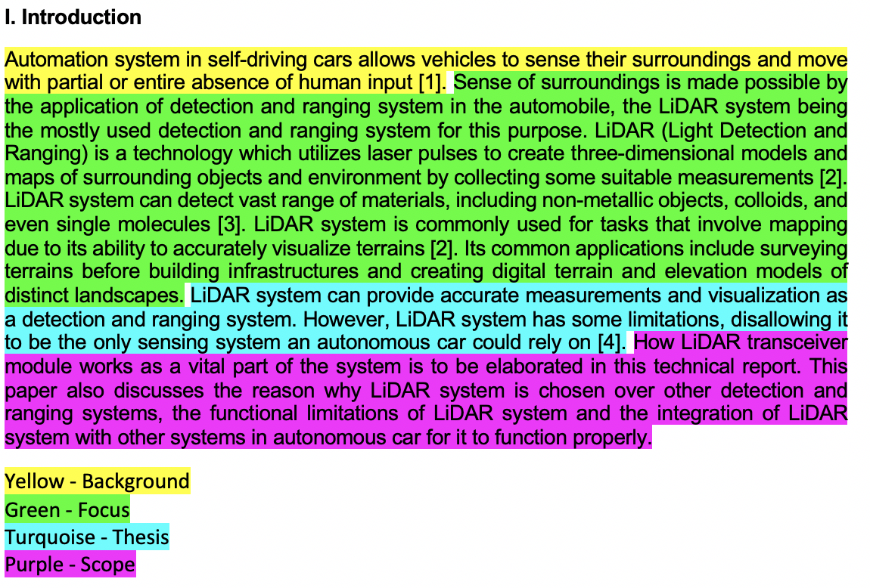*Figure 3: EG 1112 Engineering Practices and Principles II – Group Technical Report (Lee, Pratama 2019b)*

In conclusion, ES1103 has showed near transference to my major disciplinary writings as my writings have shown improvement from the first lab report to the technical report. ES1103 has helped me adopt and apply the knowledge on cohesive texts to my technical writings, especially in the aspect of thematic progression and writing introductions. While having enhanced my technical writing skills, I am grateful for being able to finish this journey and hope to further improve my subsequent writings using the concepts learned in ES1103.

Reference List

Academic discourse and the ES1103 Pedagogical Approach. (2018). *ES1103 English for*

*Academic Purposes* [Course handout]. CELC, National University of Singapore.

Cohesive texts. (2018a-d). *ES1103 English for Academic Purposes* [Course handout]. CELC,

National University of Singapore.

Lee, N., Lee, C.Y., Kumar, A., Tan, G.T., & Tan, R.Q.(2018). CELC Group Lab Report. *EG 1111*

*Engineering Practices and Principles I.* National University of Singapore.

Lee, N., & Pratama, N.S.(2019a&b). CELC Group Technical Report. *EG 1112 Engineering*

*Practices and Principles II.* National University of Singapore.

Writing Introductions. (2018). *ES1103 English for Academic Purposes* [Course handout].

CELC, National University of Singapore.